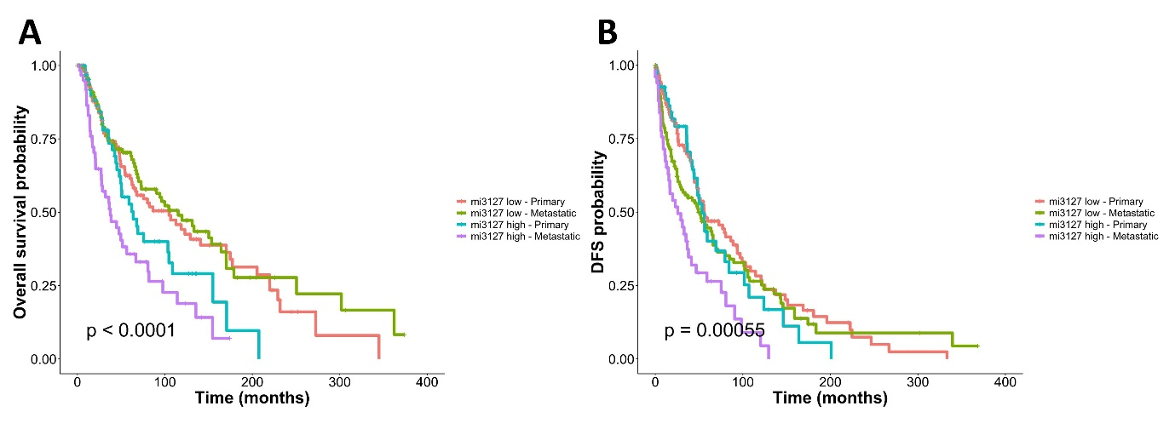

Supplementary Fig. 1. (A) Kaplan-Meier curves illustrating overall survival differences between miR-3127–low and miR-3127–high expression groups in both metastatic and non-metastatic melanoma patients. (B) Kaplan-Meier curves depicting disease-free survival comparisons between miR-3127–low and miR-3127–high expression in metastatic and non-metastatic melanoma patients.

